Facebook Campaigns
BuyIreland.com

Campaign: Australia - Female
PICTURE: 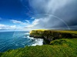
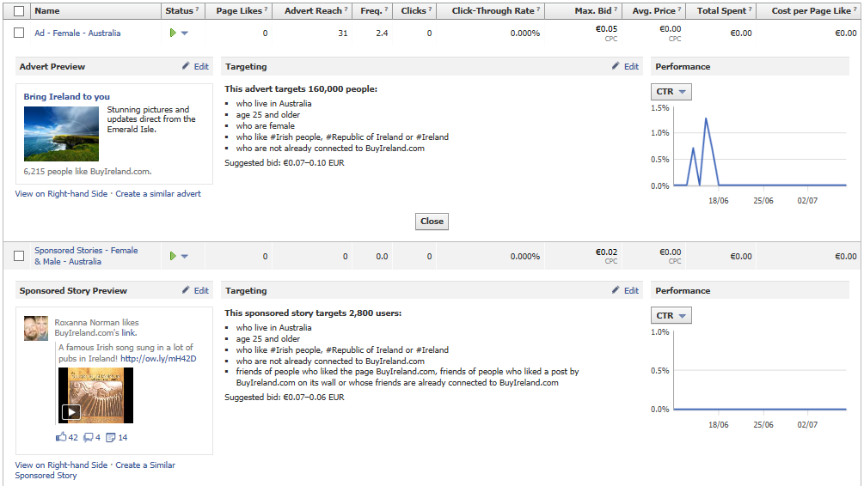

Campaign: Australia - Male
PICTURE: 
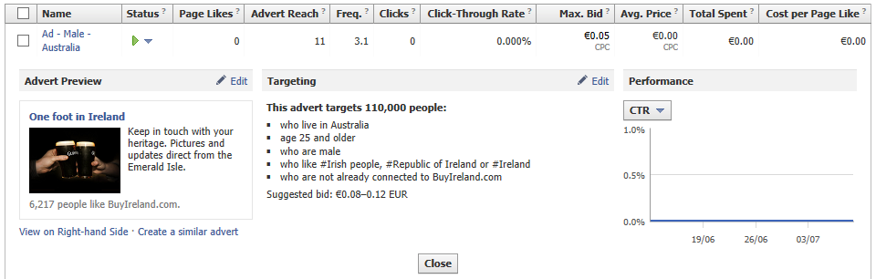

Campaign: Canada - Female
PICTURE:
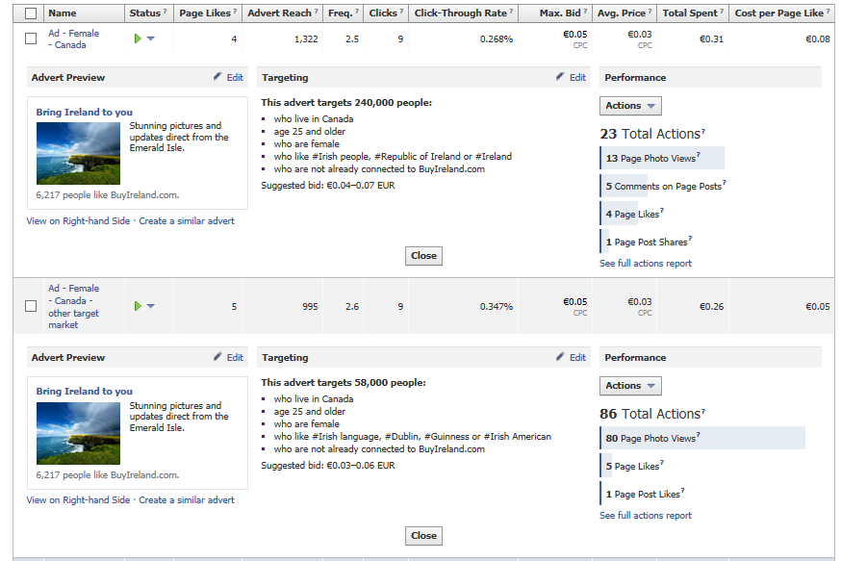
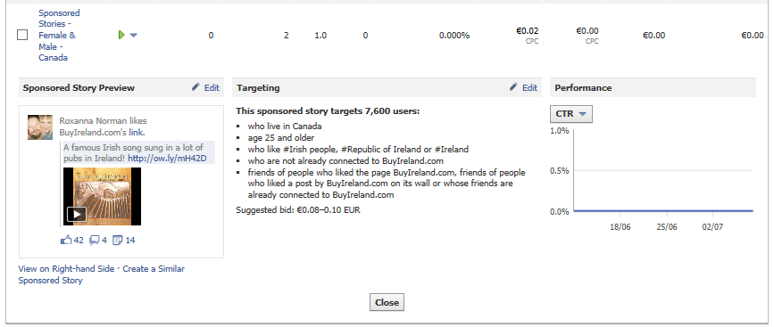

Campaign: Canada - Male
PICTURE: 
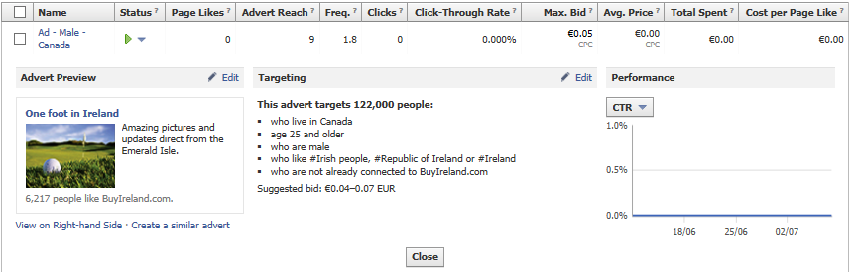

Campaign: USA - Female
PICTURE:
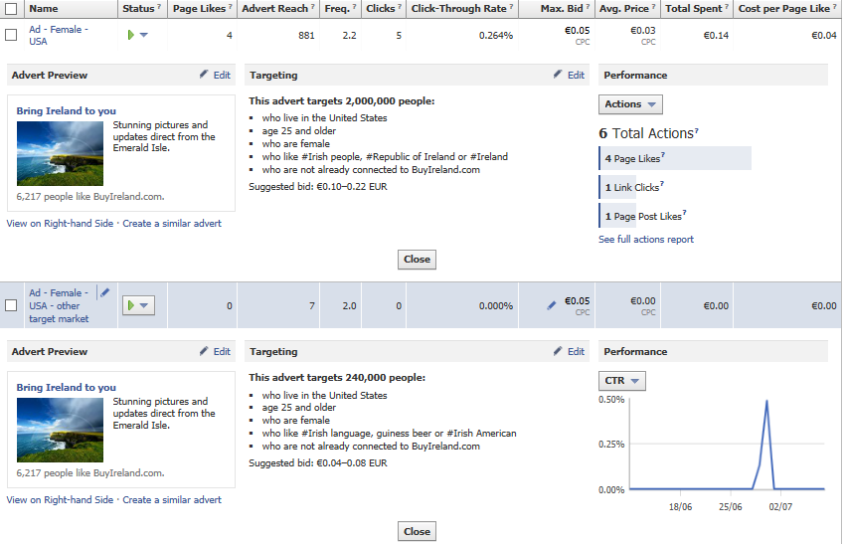
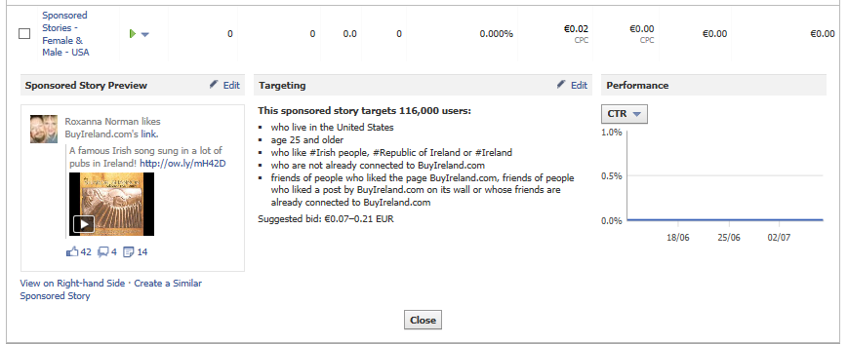

Campaign: USA - Male
PICTURE: 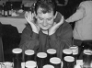
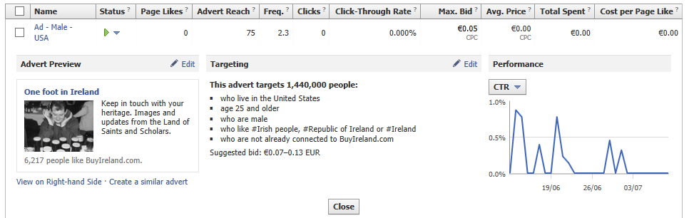

Campaign: USA – Female – CPM
PICTURE:
